**Daily Horoscope C++ project**

**The Debug Squad**

**Team Members:** Nicole Sharp, Noah Howe, Brianna Finley, and Tylyn Hines.

**Output for Zodiac tag lines**

**Code:**

**Output for Daily Affirmations**

Code:

Output for Energy check in

Code:

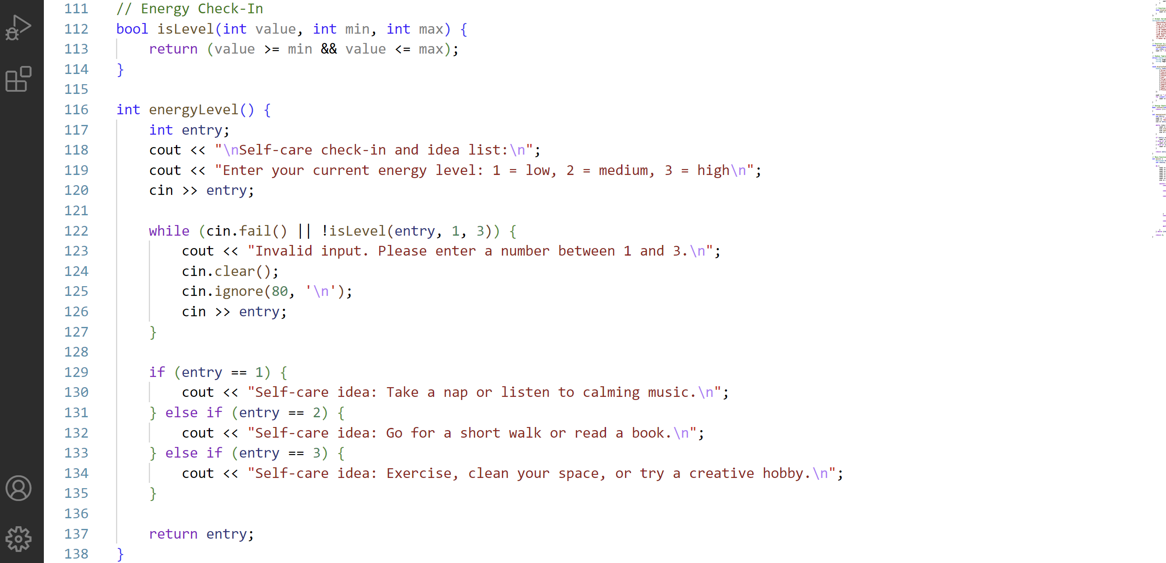

**Horoscope Check-In**

**Code:**

